**EchoCAL ZigBee Wireless Network:**

**Monitoring Network Signal Strength using DigiKey “XCTU” software.**

1. A special software package developed by Digi International called “XCTU” is used to monitor the signal strength on the EchoCAL wireless network. This program allows the operator to visually see the signal strengths of all nodes in the ZigBee wireless mesh network.
2. Plug the EchoCAL Base Station into the PCs USB port. Verify which COM port is assigned to this base station using Window’s Device Manager.
3. 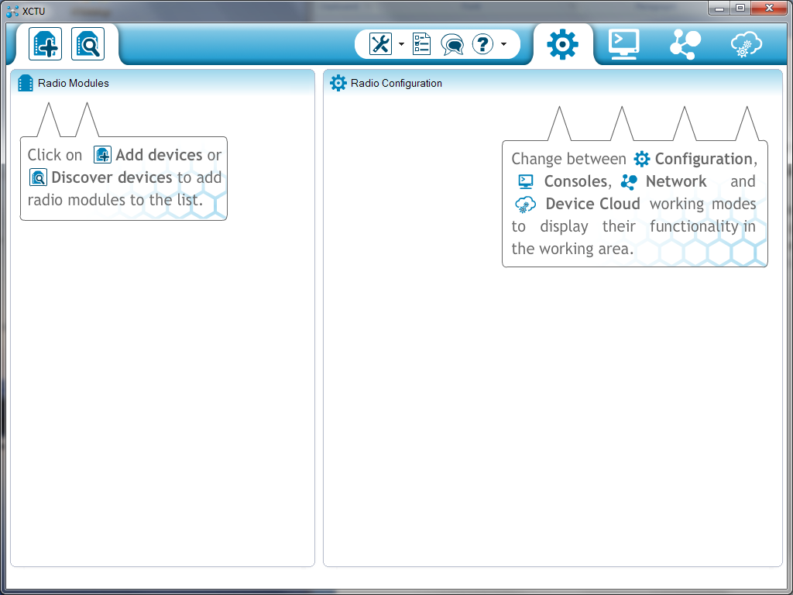Launch the XCTU software by double-clicking the XCTU icon on the PCs desktop. The XCTU main window will open on the PC.

Discover Devices Tool

1. 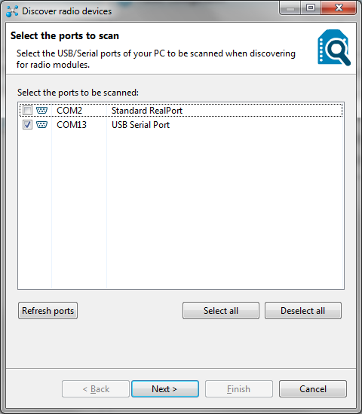Click on the “Discover devices” tool icon on the top left portion of the XCTU window. This tool allows the software to automatically locate ZigBee transceivers attached to the PC. At this point, the “Discover radio devices” window will open. Select the checkbox next to the COM port that the EchoCAL Base Station is attached to. Click on the “Next” button at the bottom of the window to continue.
2. The “Set port parameters” window will open. Verify that the Serial/USB port parameters are properly configured:

* Baud Rate: 9600,
* Data Bits : 8,
* Parity: None,
* Stop Bits: 1,
* Flow Control: None.

1. 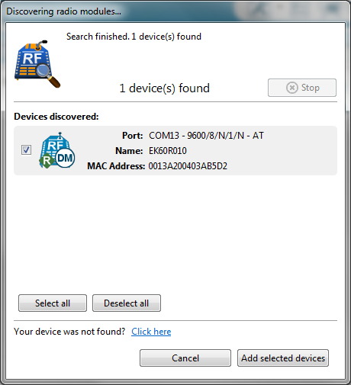Click on the “Finish” button to continue. A new window will open which will show the device discovered on the PCs COM port. When the device appears on the “Devices discovered” portion of the window, verify that the correct device has been identified. Note: The devices name should be “EK60R010”. Once the device appears, select the “Add selected devices” button to select the base station transceiver.
2. The selected transceiver will appear in the main XCTU window in the left column. Click on this device, and the transceiver’s parameters will begin loading on the right side of window. Using the scroll bar on the right side of the window, scroll down the parameter list until you get to the **“Serial Interfacing”** portion of the transceiver’s parameter list. Locate the **“AP API Enable”** parameter under the Serial Interfacing section. In normal EchoCAL operation, this parameter should be set to **“Transparent Mode [0]”**. Click on this parameter to change the setting to **“API without escapes [1]”**. This parameter will turn GREEN, indicating that a change was made to this parameter. Click on the red **“Pencil”** icon to the right of this parameter to save it to the transceiver. Once the **“Pencil”** icon is selected, the change will be written to the transceiver, and the parameter will turn BLUE in the window. This change needs to be made to allow the transceiver to query other devices on the network about their configuration settings.

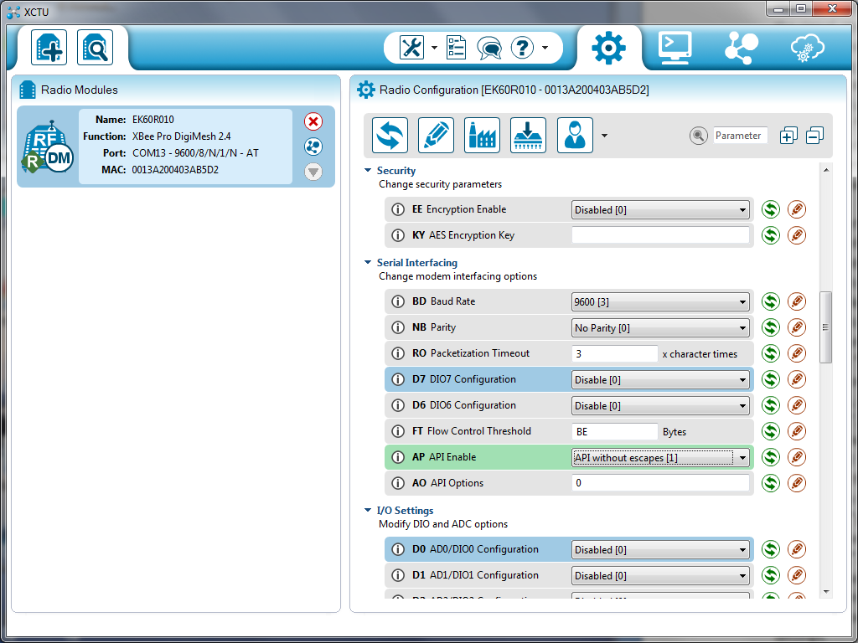

Discover radio nodes in same network icon:

1. Once the “AP API Enable” parameter has been changed, select the “Discover radio nodes in the same network” icon on the EK60R010 display on the left side of the main program window. This action will launch a new “Discovering remote devices” window, and the software will begin scanning the local wireless network for the various nodes that are available on the mesh network. Make sure all of the installed devices appear on the “New remote devices discovered” portion of this window. When all devices appear in this window, click on the **“Add selected devices”** button. This window will close, and the selected devices will appear below the base stations entry on the left column in the main XCTU window.

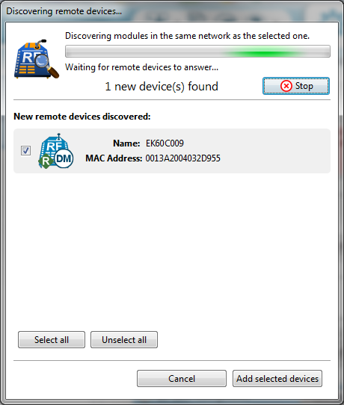

1. In the main XCTU window, select the “Switch to Networking Mode” tool icon on the right upper tool bar in the main window. The lower right portion will change to a tabbed interface showing the EK60R010 base station in the tab’s label.

Start/Stop scanning the radio module network.

1. 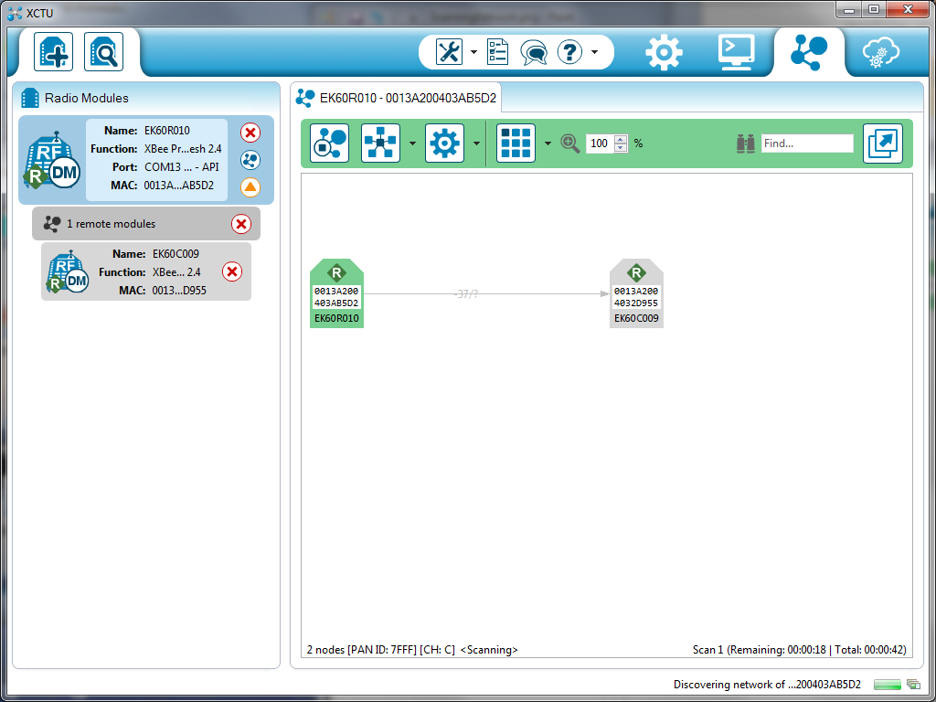In the tab toolbar portion of the window, select the “Start scanning the radio module network” tool. The lower portion of the tab window will show the EK60R010 graphic which symbolizes the EchoCAL base station. All other transceivers on the network will begin appearing, with links between different transceivers that show the transmit/receive signal power levels. Verify that all of the transceivers appear, and that there is a sufficient transmission path between all transceivers in the network. When satisfied with the performance, select the “Stop scanning the radio module network” tool in the tab’s toolbar.
2. Select the “Switch to Configuration working mode” toolbar in the main window to bring up the parameter settings for the EK60R010 base station.
3. Using the scroll bar on the right side of the window, scroll down the parameter list until you get to the **“Serial Interfacing”** portion of the transceiver’s parameter list. Locate the **“AP API Enable”** parameter under the Serial Interfacing section. Click on this parameter to change the setting back to **“Transparent Mode [0]”**. This parameter will turn GREEN, indicating that a change was made to this parameter. Click on the red **“Pencil”** icon to the right of this parameter to save it to the transceiver. Once the **“Pencil”** icon is selected, the change will be written to the transceiver, and the parameter will turn BLUE in the window. This change needs to be made to allow the transceiver to query other devices on the network about their configuration settings.
4. Click on the red X icon on the base station graphic to close the COM port to the base station. Close the XCTU program.